May 13, 2015

http://closetsamples.com/organo-coffee-review/

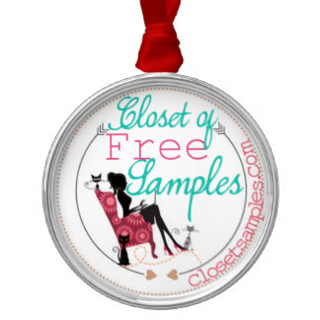

Organo Coffee #Review

Posted: 05/13/2015

By Ashley

When you say “sports drink,” coffee isn’t usually the first thing that comes to mind – so why is it Manny Pacquiao’s sports drink of choice? The world champion boxer’s favorite gourmet coffee, Organo Gold, is infused with Ganoderma, a mushroom extract used for thousands of years in traditional Asian medicine for its possible antioxidant, immune support and other beneficial attributes. Pacquiao doesn’t just drink Organo Gold: he has now signed an endorsement contract because it’s the only coffee he cares to drink. Paired with the known beneficial effects of coffee itself (improved circulation, memory and muscle preservation), the addition of Ganoderma to Organo Gold gourmet coffee produces a knock-out punch .
About Organo
When CEO and Founder Bernardo Chua began Organo Gold, he was already a successful businessman. What made this new venture unique was that it was born out of his vision and commitment to bringing the ancient Chinese herb known as Ganoderma to the rest of the world.

Shane Morand, it’s widely believed that nobody has sold more Ganoderma infused products than Organo Gold’s Co-Founder and Global Master Distributor, Shane Morand. His ability to motivate and develop leaders all over the world has been a blueprint for many of Organo Gold’s top Distributors and has helped the company expand into 6 continents. Shane’s vision and passion have been instrumental in helping Organo Gold become one of the most admired Network Marketing companies in the world.

Holton Buggs was invited to join the company and promoted to the Executive Vice President of International Sales. His in-depth knowledge of Network Marketing was a driving force behind the wide variety of complementary Organo Gold products. Holton’s Network Marketing expertise helps enable the Distributors to work with the system to build successful businesses.

I was lucky to have a chance at trying some of the Organo Gold coffee products and I am in love! I tried the Organo Gold Premium Collection Cafe Chocolate Almond Kcups, Organic Green Tea, and the premium gourmet king of coffee with organic ganoderma lucidum spores. Each item had it’s own unique flavor, but of the 3 the chocolate almond coffee was my favorite. It has an actual chocolate taste to it! I tried mine straight without any added sugar or cream and it was delicious, but adding some cold milk and a small spoon of sugar just amplified how much better it made it! It went down smoothly with a premium flavor/taste to it – I’m not sure how else to describe it. It’s one of those coffees that taste the same way that it smells if that makes sense. After this experience I can honestly say I recommend trying Organo Gold coffee products!

